
VISA International
Asia-Pacific Region

ECS 3.0
TCP/IP
Questionnaire
SECTION A

VISA MEMBER
CONTACT
INFORMATION

A.1 Member Name: Joint Development Bank, Laos

Member Address:

BIN:

A.2 Center Manager:

A.3 Project Implementation Contacts

Project Contact Name:

Designation/Department:

Tel.: Ext.: Fax:

Back Up Project Contact Name:

Designation/Department:

Tel.: Ext.: Fax:

Address for router and switch installation, please include which floor
( if this address is the same as A1 please state “as above” ):
1

Equipment Setup Contact Name:

Tel.: Ext.: Fax:

Network Link Installation/Upgrade Contact Name:

Tel.: Ext.: Fax:

A.4 Daily Operation Contacts:

Main Operations Contact:

Tel.: Ext.: Fax:


Card Centre Emergency Contact:

Telephone: Ext.: Fax:

Network Operations Contact:

Telephone: Ext.: Fax:

Centre Operating Hours (in local time):

NOTE:
If your Operations Centre is not attended 24 hours a day, please provide a contact that can be reached in emergency circumstances.
SECTION B

OVERVIEW

ECS 3.0

The Express Connect Service (ECS) is a client/server application consisting of Express Connect Client (ECC) and a modified VisaNet Access Point (VAP) called the ECS Server. The service provides the member with a gateway to a subset of Visa systems and services.

The ECS is configured to perform the following basic VisaNet functions:
- Interface between the member and the V.I.P. System to perform credit authorization processing, Single Message System (SMS) processing, or both
- Interface between your ECC and VIC to exchange BASE II Clearing & Settlement files
- Support inventory file processing for file receipt verification
- Support VisaNet Certification Management Service (VCMS)

The TCP/IP capabilities of Express Connect Service (ECS) will allow for a central router within the country to be established to consolidate all ECS member traffic within the country before backhauling the traffic to the central ECS servers. This will allow the sharing of International Leased Circuits (ILCs). In addition there is more flexibility in the use of other network technologies (e.g. IP VPN, Private Frame-Relay).

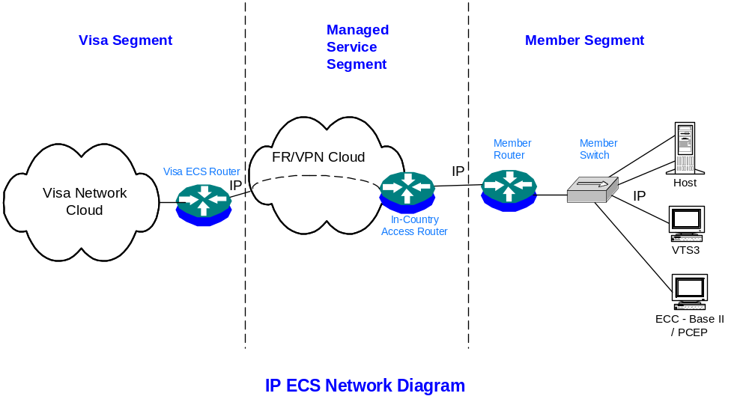
SECTION C

STATION ID Information
(To Be Completed by Member Services)

Description | STATION ID
ECS Prod Station ID
ECS VCMS1 Station ID
ECS VCMS2 Station ID [Optional]
 | CREDIT # | MIS # | CAS #
Member Prod Host #1
(Base-1 / SMS)*
Member Prod Host #2 [Optional]
(Base-1 / SMS)*
Member VCMS Host #1
(Base-1 / SMS)*
Member VCMS Host #2 [Optional]
(Base-1 / SMS)*
Visa Test System 3 (VTS3)

* Delete where Applicable
# Only VIP Message Format is supported

BASE-II BIN Information
(To Be Completed by Member Services)

BASE II BINs | (1)
BASE II BINs | (2) | Optional
BASE II BINs | (3) | Optional
BASE II BINs | (4) | Optional

SECTION D

IP ADDRESS INFORMATION
(For Member Usage)

ECS Servers IP Address

Description | IP Address
ECS Production Server #1 | 172.30.99.13
ECS Test Server #1 | 172.30.99.14
ECS Base II Server #1 | 172.30.99.14

Member IP Address Assignments (To Be Assigned by VISA)

Description | IP Address
Member Network Address | 172.30.108.16
Netmask | 255.255.255.240
Default Gateway | 172.30.108.17

Description | Assigned IP Address @ | Netmask | Destination ECS Server | Destination TCP Port
Member Production Host #1 | 172.30.108.21 | 255.255.255.240 | Production Server #1 | 8021
Member Production Host #2  [Optional] | 172.30.108.22 | 255.255.255.240 | Production Server #1 | 8022
Member VCMS Host #1 | 172.30.108.24 | 255.255.255.240 | Test Server #1 | 8024
Member VCMS Host #2  [Optional] | 172.30.108.25 | 255.255.255.240 | Test Server #1 | 8025
Visa Test System 3  (VTS3) | 172.30.108.20 | 255.255.255.240 | Test Server #1 | 8020
Express Connect Client (ECC) | 172.30.108.19 | 255.255.255.240 | Base II Server #1 | 18019

Example :

Description | Assigned IP Address | Netmask | Destination ECS Server | Destination TCP Port
Member Production Host #1 | 172.30.123.138 | 255.255.255.240 | Production Server #1 | 8000

Member Production Host #1 (IP address 172.30.123.138) will connect to ECS Production Server #1
(IP address 172.30.99.11) using destination TCP port 8000.

@ Member host MUST use the Addresses assigned by VISA for the respective application.
SECTION E

Member Implementation
Requirements
This document provides the member with information on the implementation requirements of the ECS. The second portion of the document is a questionnaire which will gather information about the physical conditions related to the location of the equipment.

- ECS Hardware and Software Requirements

VISA Provision / Responsibility

S/N | Equipment / Item | Qty | Function / Remarks
1 | Cisco Router 2600 series | 1 | WAN Connectivity
2 | Cisco Catalyst Switch 2900 series | 1 | Ethernet Switching
3 | Cisco cable DTE V.35, 10ft | 1 | Connection to WAN
4 | UTP cables | 6 | Switch to Member Host Connections
5 | ECC vftp client software | 1 | Base II File Transfer
6 | PC-Edit Package software * | 1 | Base II File Transfer
7 | VTS3 software * | 1 | Certification

Member Provision / Responsibility

S/N | Equipment / Item | Qty | Function / Remarks
1 | Complete Intel Pentium 100 or Higher | 1 | Systems for Base II File Delivery and PC-Edit Package
 | - PCI Bus Support
 | - RAM (min. 64 MB) |  | Recommend 128MB
 | - Free hard disk space (min. 350MB)
 | - Video display (1MB or more)
 | - Monitor (SVGA)
 | - Standard Windows compatible mouse
 | - CD ROM drive
 | - 31/2-inch floppy disk drive
 | - Ethernet Card (10/100Mb)
 | - WIN 98 ; WIN 2K SP1
2 | Complete Intel Pentium III, 550 or Higher | 1 | Systems for VTS3
 | - PCI Bus Support
 | - RAM (min. 64 MB) |  | Recommend 128MB
 | - Free hard disk space (min. 2GB) |  | Recommend 4GB
 | - 1024x768 Monitor (SVGA)
 | - Standard Windows compatible mouse
 | - CD ROM drive
 | - 3½ -inch floppy disk drive
 | - Ethernet Card (10/100Mb)
 | - WIN NT 4.0 SP6 ; WIN 2K SP1 |  | Installed with Remote Access Service

* The PC-Edit Package software and VTS3 software are supplied by VISA, but chargeable to member.

- EQUIPMENT

Member is required to reserve space for the ECS equipment – the Cisco router, switch and the NTU/modem. The ECS’ router and switch can be rack-mounted or placed on a shelf.
The dimension of the 2600 router: 1.69 x 17.5 x 11.8 in (4.3 x 44.5 x 30 cm).
The dimension of the 2900 switch: 1.72 x 17.5 x 9.52 in (4.4 x 44.5 x 24.2 cm).

The NTU/modem provided by the Telco or Network Service Provider should be placed on a shelf near to the router.

- CABLE

Visa will provide 10 Ethernet UTP switch cables for connectivity to the member hosts/PCs. The length of the cables are 10-feet. If member hosts/PCs are more that 10-feet away, member is to prepare their own extension cables.

- POWER

The ECS equipment will require a minimum of 2 x 13A power points. It is strongly suggested that the power source to the ECS be from a stable source and be supported by an uninterruptible power supply (UPS).

- VENTILATION

The ECS equipment must be kept in a dry (non-humid) environment.
The ECS equipment will require adequate ventilation/cooling to prevent overheating. It is highly recommended that the ECS be placed in an air-conditioned environment.

- SECURITY

The ECS equipment should be located in a secure location with controlled access to prevent tampering with the equipment.

- OTHER CONSIDERATION

The equipment and its cables must be placed away from sources of electro-magnetic interference (EMI) such as electric motors, fluorescent lights, heavy machinery and high voltage electrical equipment.

- Member is able to meet space requirements for
the ECS equipment : Yes No

- Member is able to meet the power requirements for
the ECS equipment : Yes No

- The ECS equipment power source is going through an
uninterruptible power supply : Yes No

- The ECS equipment will be placed in an air-conditioned
environment Yes No

- The ECS equipment will be placed away from EMI
sources : Yes No

NOTE: The above questionnaire is to be “Yes” for all requirements in order for Visa to deploy ECS equipment.

